REPORT

On contract research for

##### **BKS ENGINEERS (Pty) Ltd**

Lnrlogo

**MITCHELL’S PLAIN-PHILIPPI**

**AND FIRGROVE-MITCHELL’S PLAIN**

**TRANSMISSION LINE ROUTES,**

**WESTERN CAPE**

By

D.G. Paterson & F.T. Seabi

Report Number GW/A/2010/40

May 2010

ARC-Institute for Soil, Climate and Water,

Private Bag X79, Pretoria 0001, South Africa

Tel (012) 310 2500 Fax (012) 323 1157

**CONTENTS Page**

1. **TERMS OF REFERENCE 3**
2. **SITE CHARACTERISTICS 3**
3. **METHODOLOGY 5**
4. **MITCHELL’S PLAIN-PHILIPPI 6**
5. **FIRGROVE-MITCHELL’S PLAIN 8**

**6. PYLON POSITIONS 10**

1. **CONCLUSIONS 11**

**REFERENCES 12**

**APPENDIX: SOIL MAPS**

**1. TERMS OF REFERENCE**

The ARC-Institute for Soil, Climate and Water (ARC-ISCW) was contracted by BKS (Pty) Ltd to undertake a soil investigation between Philippi and Firgrove, south-east of Cape Town in Western Cape Province. The purpose of the investigation is to contribute to the Environmental Impact assessment (EIA) process for a proposed 400 kV double circuit transmission line from Firgrove to Mitchell’s Plain and a proposed 400 kV single circuit line from Mitchell’s Plain to Philippi. The objectives of the study are:

* Using existing information, to classify the soils and to produce a soil map of the specified areas as well as
* To assess broad agricultural potential.

**2. SITE CHARACTERISTICS**

* 1. **Location**

The two corridors under investigation run as follows:

* Firstly, from the existing Philippi substation (co-ordinates 33o 29’ 51” S, 18o 32’ 14” E) south-east to a new substation in the vicinity of the existing Mitchell’s Plain substation (co-ordinates 34o 01’ 16” S, 18o 36’ 18” E).
* Secondly, from Mitchell’s Plain approximately east to the existing Firgrove substation (co-ordinates 34o 02’ 56” S, 18o 46’ 57” E). This corridor also includes an option connecting the new substation at Mitchell’s Plain to the existing Sitkland substation, north of Kuils River.

The locality is shown in Figure 1.

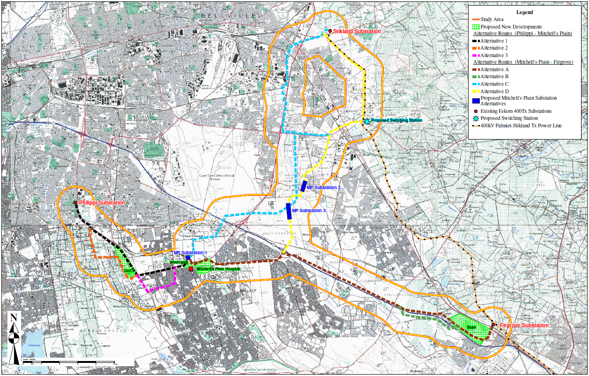

**Figure 1** Locality map showing both corridors

* 1. **Terrain**

The area is located on the Cape Flats consists of virtually flat to slightly undulating topography. The routes lie generally at an altitude of less than 40 meters above sea level.

* 1. **Climate**

The climate of the area (Koch & Stehr, 2003) can be regarded as typical of the Cape west coast, with a low, all-year round rainfall distribution, warm to hot summers and cool winters. The main climatic indicators are given in Table 1 below.

**Table 1** Climate Data

|  |  |  |  |  |
| --- | --- | --- | --- | --- |
| **Month** | **Rainfall (mm)** | **Min. Temp (oC)** | **Max. Temp (oC)** | **Average frost dates** |
| Jan | 14.5 | 15.5 | 29.5 | Start date:  End date:  Days with frost: - |
| Feb | 14.7 | 15.6 | 29.8 |
| Mar | 13.8 | 14.4 | 28.4 |
| Apr | 48.9 | 11.9 | 25.3 |
| May | 76.7 | 9.2 | 21.5 |
| Jun | 89.2 | 6.9 | 18.4 |
| Jul | 89.0 | 5.7 | 17.6 | **Heat units (hrs > 10oC)** |
| Aug | 79.9 | 5.9 | 18.4 | Summer  (Oct-Mar):  Winter  (Apr-Sept): |
| Sep | 45.9 | 7.4 | 20.3 |
| Oct | 32.7 | 9.4 | 23.3 |
| Nov | 21.7 | 12.4 | 26.3 |
| Dec | 14.8 | 14.3 | 28.2 |
| **Year** | **524.7 mm** | **17.3oC (Average)** | |

The extreme high temperature that has been recorded is 43.0oC and the extreme low –0.5ºC.

* 1. **Parent Material**

Most of the area comprises aeolian sands of the Witzand Formation (Geological Survey, 1990).

**3. METHODOLOGY**

The whole of the country is covered by land type data at 1:250 000 scale. However, most of the study area occurs within the boundary of the coverage by 1:50 000 scale soil maps (Jacobs, Oosthuizen & Stehr, 2003). It was therefore decided to use this information. In the 1:50 000 scale survey, soil mapping units were established according to dominant and sub-dominant soil forms, which could then be allocated to a class of general agricultural potential.

However, the portion of the routes that occur on the 1:50 000 map sheet 3418BB Somerset West has not yet been finalized and has consequently not yet been digitized and added to the rest of the survey. In order to incorporate this information in the map, the provisional information was checked and correlated so that lines could be drawn and the map was then digitised to produce the version included in the Appendix.

**4. MITCHELL’S PLAIN-PHILIPPI**

**4.1 Soils**

The area consists mainly of moderately deep to deep, fine- to medium-grained, grey to yellow sandy soils, dominantly of the Fernwood (Fw) and Namib (Nb) soil forms. Where the sandy soil has a subsoil clay horizon (“duplex” soil character), these soils belong mainly to the Kroonstad (Kd) and Katspruit (Ka) soil forms. Smaller areas of shallow soils with a structured clay or hardpan carbonate subsoil also occur.

A summary of the main soil characteristics is given in **Table 2** below (with corresponding colours as shown on the map).

*(Note: the mapping units on the 3418 Somerset West 1:50 000 map sheet were digitized separately from another soil survey, so their symbols have no number added on).*

**Table 2** Soil mapping units of the Mitchell’s Plain-Philippi route

|  |  |  |  |
| --- | --- | --- | --- |
| **Map Unit** | **Dominant**  **Soil form** | **Soil characteristics** | **Agricultural Potential** |
| **dNb** | Namib | Deep (>1 200 mm), yellowish-grey, eluvial sands | Low to moderate |
| **dFw** | Fernwood | Deep (>1 200 mm), yellowish-grey, aeolian sands | Low to moderate |
| **dLt** | Lamotte | Deep (>1 200 mm), yellowish-grey, eluvial sands with a dark brown to reddish-brown subsurface horizon with iron and organic matter accumulation | Low to moderate |
| **mdLt** | Namib | Moderately deep to deep (600-1 200 mm), yellowish-grey, eluvial sands with a dark brown to reddish-brown subsurface horizon with iron and organic matter accumulation | Low to moderate |
| **sKd** | Kroonstad | Shallow (300-600 mm), grey to brown, sandy soils overlying mottled, usually structured, hydromorphic loamy sand to clay loam subsoils; often in low-lying positions | Low |
| **sKa** | Katspruit | Shallow (200-400 mm), grey to black, fine to medium sandy to sandy loam topsoils, on hydromorphic clay loams to clay subsoils; often in low-lying areas. | Very low |
| **dWb** | Witbank | Disturbed or excavated areas | Very low |
| **U** | - | Built up areas that were not surveyed | None |

**Note:** where the same mapping unit is shown with a different number attached, eg dNb1, dNb4 etc, this simply refers to a separate occurrence of the same mapping unit, as referred to in the table above

* 1. **Agricultural Potential**

The sandy soils that predominate in the study area (deep Fernwood/Namib) have a low to moderate agricultural potential. Although these sandy soils are freely-drained and easy to work, they are prone to droughtiness, due to the low clay content (often <10%), and they are not very fertile, with much of the nutrients having been leached out. They may also have a susceptibility to wind erosion if exposed, caused by the fine to medium grade of sand.

The podzols (Lamotte form), may have a slightly higher clay content, but are often more acidic, with a lower pH. However, adding organic matter and fertiliser to all of these sandy soils can often make them productive.

The duplex soils (mainly Kroonstad) have a subsoil clay horizon (often at a shallow depth) which can often result in a wetness/flooding hazard, so these duplex soils have a low potential.

**5. FIRGROVE-MITCHELL’S PLAIN**

**5.1 Soils**

The area consists mainly of a mixture of soils. Moderately deep to deep, fine- to medium-grained, grey to yellow sandy soils, dominantly of the Namib (Nb) soil form, occur mainly in the west, while shallower, duplex soils (sandy topsoil abruptly overlying a structured clay subsoil) of the Kroonstad (Kd) or Estcourt (Es) soil forms are found more toward the east. An area of wetland soils of the Katspruit (Ka) soil form is found next to the Kuils River, just east of Khayelitsha and the Eerste River itself.

A summary of the main soil characteristics is given in **Table 3** below (with corresponding colours as shown on the map).

**Table 3** Soil mapping units of the Firgrove-Mitchell’s Plain route

|  |  |  |  |
| --- | --- | --- | --- |
| **Map Unit** | **Dominant**  **Soil form** | **Soil characteristics** | **Agricultural Potential** |
| **dNb** | Namib | Deep (>1 200 mm), yellowish-grey, eluvial sands | Low to moderate |
| **dHu** | Hutton | Deep (> 1 200 mm), red, sandy loam soils | Moderate to high |
| **mdNb** | Namib | Moderately deep (600-1 200 mm), yellowish-grey, eluvial sands, often on cemented hardpan carbonate | Low to moderate |
| **mdKd** | Kroonstad | Moderately deep (600-1 200 mm), grey to brown, sandy soils overlying mottled, usually structured, hydromorphic loamy sand to clay loam subsoils. | Low to moderate |
| **sNb** | Namib | Shallow (300-600 mm), yellowish-grey, eluvial sands, usually on cemented hardpan carbonate | Low |
| **sGs** | Glenrosa | Shallow (300-600 mm), grey-brown, loamy topsoils on weathering rock | Low |
| **sKd** | Kroonstad | Shallow (300-600 mm), grey to brown, sandy soils overlying mottled, usually structured, hydromorphic loamy sand to clay loam subsoils; often in low-lying positions | Low |
| **sKa** | Katspruit | Shallow (300-500 mm), grey to black, fine to medium sandy to sandy loam topsoils, on hydromorphic clay loams to clay subsoils; often in low-lying areas. | Very low |
| **vsKa** | Katspruit | Very shallow (100-300 mm), grey to black, fine to medium sandy to sandy loam topsoils, on hydromorphic clay loams to clay subsoils; in low-lying areas. | Very low |
| **Vlei** | Katspruit | Virtually permanent wetland areas, surface water and hydromorphic soils | None |
| **U** | - | Built up areas that were not surveyed | None |

**Note:** where the same mapping unit is shown with a different number attached, eg dNb1, dNb4 etc, this simply refers to a separate occurrence of the same mapping unit, as referred to in the table above.

**5.2 Agricultural Potential**

The sandy soils that predominate in the study area (deep Namib soils) have a low to moderate agricultural potential. Although these sandy soils are freely-drained and easy to work, they are prone to droughtiness, due to the low clay content (often <10%), and they are not very fertile, with much of the nutrients having been leached out. They may also have a susceptibility to wind erosion if exposed, caused by the fine to medium grade of sand.

However, adding organic matter and feriliser to all of these sandy soils can often make them productive.

The duplex soils (mainly Kroonstad, occasionally Estcourt) have a sandy topsoil abruptly subsoil clay horizon (often at a shallow depth) which can often result in a wetness/flooding hazard, so these duplex soils have a low potential. This is especially prevalent in the lowest parts of the landscape, especially close to the rivers.

**6 PYLON POSITIONS**

At a workshop held in Pretoria in March 2011, all of the proposed pylon positions for each route alternative were analysed for the potential impact on the soils occurring, from an agricultural viewpoint.

The rating that was used allocated the following classes:

0 – no impact

**1 – low impact**

**2 – medium impact**

**3 – high impact**

Using the soil maps (as in the Appendix), the ratings were applied for each route and the results were as follows:

***PHILIPPI - MITCHELL’S PLAIN***

**Alternative 1** – only PM-1-18 is medium, all the rest are low or no impact.

**Alternative 2** – all site are medium, as this is an area of agricultural holdings

**Alternative 3** – all sites are no impact

**Alternative 4** – all sites are medium, as this area also has some agricultural holdings.

***FIRGROVE - MITCHELL’S PLAIN***

**Alternative A** – all sites are low or no impact (no areas with agriculture and good soils are traversed)

***MITCHELL’S PLAIN - STIKLAND***

**Alternative C** – all sites are no impact

**Alternative D** – only MS-D-33 and 34 are moderate (agricultural land near Polkadraai Road), all other sites are low or no impact

# 7 CONCLUSIONS

The soils are generally sandy, freely-drained, but lacking somewhat in fertility. Where subsoil clay horizons occur, they may well be prone to waterlogging. However, as long as care is taken in crossing wetlands or rivers, there is no fatal flaw that can be identified at this stage.

The impact of a transmission line is comparatively small, with small, isolated “footprints” for each separate pylon, as long as irrigated areas are not impacted. A request was made by the Western Cape Provincial Department of Agriculture to address the possibility of “unique soils” occurring in the study area. Due to the prevailing sandy nature of the soils, and associated fertility depletion, it is extremely unlikely that “unique" soils occur in the area, and there has been no project that has mapped such soils, especially at a detailed scale. The soil investigation has identified the areas of varying potential in order that comparisons may be made.

**REFERENCES**

**Geological Survey**, 1990. 1:250 000 scale geological map 3318 Cape Town. Department of Mineral and Energy Affairs, Pretoria.

**Koch, F.G.L. & Stehr, B.I.,** 2003. Climate data. *In:* Land types of the map 3318 Cape Town. *Mem. Agric. nat. Res. S. Afr*. No. 24. ARC-Institute for Soil, Climate and Water, Pretoria.

**Jacobs, E.O., Oosthuizen, A.B. & Stehr, B.I.,** 2003. Soils of the Cape Metropolitan area (Second edition). Report No. GW/A/1999/83, ARC-Institute for Soil, Climate and Water, Pretoria.

**Soil Classification Working Group**, 1991. Soil classification. A taxonomic system for South Africa. ARC-Institute for Soil, Climate and Water, Pretoria.

**APPENDIX:**

## SOIL MAPS

## MITCH_PHIL

## FIRG_MITCH_STIK

**N**

Hu (lm)

**5.7 ha**